**MCA 2nd Semester**

**Name:- Hemant Kumawat**

**Roll No:- 13**

**Subject:- Cloud Computing**

**Topic:- GCP Deep Learning VM Image**

The Deep Learning VM Image is a pre-configured virtual machine (VM) image provided by Google Cloud that comes with a range of popular deep learning frameworks, libraries, and tools pre-installed. This image is designed to make it easier for developers and data scientists to start working on deep learning projects without the need to manually install and configure software.

**How it Works:**

1. **Pre-configured Environment:**

The VM image includes an operating system (such as Ubuntu) along with pre-installed deep learning frameworks like TensorFlow, PyTorch, Keras, and others. It also comes with GPU support and various libraries for data processing and model training.

1. **Deployment:**

Users can deploy a Deep Learning VM from the Google Cloud Console or via the gcloud command-line tool. When creating a VM, you can select a Deep Learning VM Image from the list of available images.

1. **Customization:**

While the VM image is pre-configured, you can still customize it according to your needs. You can install additional software, adjust configurations, or modify the VM as needed for your specific tasks.

1. **Integration with GCP Services:**

The Deep Learning VM can easily integrate with other Google Cloud services, such as Google Cloud Storage for storing datasets, BigQuery for data analysis, and AI Platform for managing machine learning workflows.

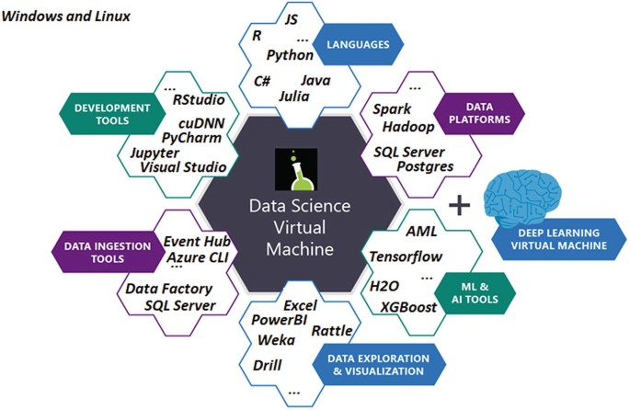

**Advantages:**

1. **Ready to Use:**

Comes with all the necessary tools already installed.

1. **Scalable:**

You can easily adjust the power of the computer depending on your needs.

1. **Flexible:**

Works with different types of powerful computers, like those with graphics cards (GPUs).

1. **Integrates Well:**

Works smoothly with other Google Cloud services.

**Disadvantages:**

1. **Cost:**

Can be expensive, especially for powerful computers.

1. **Management:**

You need to manage and optimize the usage to avoid high costs.

1. **Overkill for Small Projects:**

Might be too much for simpler tasks.

1. **Tool Versions:**

The tools might not always be the exact versions you need.

**Where it is Used**

1. **Research and Development:**

Researchers and data scientists use these VMs for developing and experimenting with new deep learning models. The pre-installed frameworks and tools save time and reduce setup complexity.

1. **Training Models:**

The VMs are often used for training large-scale deep learning models that require significant computational resources. The inclusion of GPUs or TPUs helps accelerate the training process.

1. **Testing and Prototyping:**

Developers use the Deep Learning VM Images to quickly prototype models and test new ideas before scaling them up to larger environments or production.

**Real-Life Implementations:**

1. **Image Recognition:**

A company developing a product for medical image analysis might use a Deep Learning VM to build and train a convolutional neural network (CNN) for detecting abnormalities in X-ray or MRI scans.

1. **Natural Language Processing (NLP):**

A startup focused on creating a chatbot or language translation service can use the VM to develop and fine-tune NLP models using frameworks like TensorFlow or PyTorch.

1. **Autonomous Vehicles:**

Automotive companies working on self-driving technology might leverage Deep Learning VMs for developing models that analyze sensor data and make real-time driving decisions.

1. **Recommendation Systems:**

E-commerce platforms or content streaming services can use the VMs to build recommendation algorithms that suggest products or content based on user behavior and preferences.

By providing a ready-to-use environment with the necessary tools and frameworks, Deep Learning VM Images on GCP help reduce the overhead associated with setting up deep learning projects, allowing teams to focus more on development and innovation.

Resource:-[Deep Learning VM Images  |  Google Cloud](https://cloud.google.com/deep-learning-vm/)